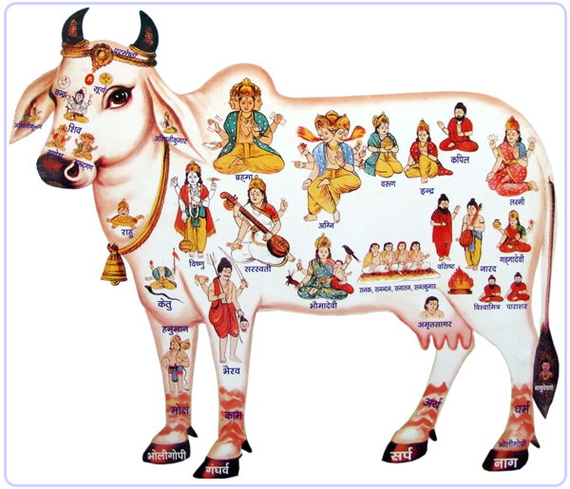 Picture of the mythological Kamadhenu - (Sanskrit) [from kama desire, wish + dhenu milk cow]
Nepal’s national animal is the cow, Most of the people of Nepal are Hindus and the cow is worshipped as the goddess of wealth (Goddess Laxmi).The holy cow is respected as the mother, as she gives us milk, that is why the cow is called ‘gau mata’– mother cow.
The five products (pancagavya) of the cow — milk, curds, ghee butter, urine and dung — are all used in puja. From cow’s milk, yogurt and then butter is made. From butter, ghee is made. Milk, yogurt and ghee are three of the five important ingredients of panchamrit, used in puja rituals. Ghee is also used for lighting divas in puja. Cowdung is used as fuel in the rural areas of Nepal even today. The dung is made into fuel cakes and used in fires to cook food in villages.
Cowdung is also used in the plastering of walls and floors of rural homes. Cow dung and cow urine have antiseptic properties , this is what modern science has discovered.
According to the shashtras, It is the general belief that the devas live in the body of the cow. That is why it is declared that nobody should kill a cow.
The Vedas are also associated with the cow. The back of the cow is believed to be the Rig Veda, her mouth the Sam Veda and the body the Yajur Veda.
Giving a cow as donation to a Brahmin is considered a highly meritorious act.- Gau-daan.
Lord Krishna, appeared 5,000 years ago as a cowherd, and is often described as bala-gopala, "the child who protects the cows." Another of Krishna's holy names, Govinda, means "one who brings satisfaction to the cows." Other scriptures identify the cow as the "mother" of all civilization, its milk nurturing the population.
In the hindu holy book the Srimad-Bhagavatam, Krishna states that “The cows, and the defenceless creatures are my own body.”
All throughout the Vedic literature, it is mentioned how dear the cows are to Krishna, and how important they are in human civilization.
Kamadhenu, (wish-fulfilling cow) the sacred cow who grants all wishes and desires, is an integral part of Hindu mythology. This divine cow, resides in heaven, she emerged from the ocean of milk at the time of the great churning of the ocean by the gods and demons. Kamadhenu's complexion is like the white clouds. Every part of her body has a religious significance. All cows are venerated in Hinduism as the earthly embodiment of Kamadhenu.
Further reading:
Kamadhenu the wish fulfilling cow:
http://www.harekrsna.de/kamadhenu.htm
CBBC Newsround: Nepal police capture cows to stop road accidents http://www.bbc.co.uk/newsround/22002742

